Bunts Sangha’s
S. M. Shetty College of Science, Commerce & Management Studies
Permanently Affiliated to University of Mumbai
NAAC Re-Accredited ‘A+’ Grade
ISO 21001:2008 Certified
IMC RBNQ Certified of Merit 2019


Project Title : Water Purity Prediction Model
Student Name : Ritu Chaurasia
Course Name : Data Engineering
Instructor Name : Mithilesh Chauhan

College : Bunts Sangha’s S. M. Shetty College of Science, Commerce & Management Studies
Class : TYBsc Data Science

Date of Submission : 27nd Aug, 2024

For Partial Fulfillment for Degree of
Bachelor of Science in DS (Data Science) in 2024-25

Table of Content
- Introduction 3
1.1 Objective 3
1.2 Problem Statement 3
1.3 Data Description 3

2. Methodology 5
  - Tools Used 5
2.2 Steps Taken 5

3. Results 9
  - Key Findings 9
3.2 Visuals 3

4. Conclusion 11
  - Summary 11
4.2 Suggestions 11

5. References 11

1. Introduction
1.1 Objective
Using many water quality measures like pH, solidity, hardness, and turbidity, this project aims to create a predictive model for evaluating the purity of water. The model utilizes machine learning techniques to precisely forecast the purity levels of water samples. This will help identify sources of safe and clean water and enhance public health outcomes.

1.2 Problem Statement
- For the sake of public health, drinking water quality and safety must be guaranteed. Traditional techniques of testing water, however, can be costly and time-consuming.
- The ability to create a machine learning model that can forecast water purity based on important quality is made possible by the growing availability of digital tools and data.
- In order to assess if a water is safe to drink, it is necessary to develop an accurate and effective prediction model that can examine a variety of water quality indicators.
- In order to guarantee safe drinking water, this model will assist in promptly evaluating the quality of the water and helping to make well-informed judgments.

1.3 Data Description
- I have used Water Potability Dataset from Kaggle for predicting the water Quality.
- In that dataset there are 10 columns namely pH, sulphate, solid, hardness, Organic_carbon, Trihalomethanes, Turbidity, Chloramines, Conductivity and Potability .
- each column have its own importance in water. Out of all columns PH column have a most significant in that dataset.
- A small overview for important of each columns for prediction.

- Ph: PH is an important parameter in evaluating the acid–base balance of water. It is also the indicator of acidic or alkaline condition of water status.
- Sulphate: Represents the concentration of sulphate ions in the water. High levels can affect the taste and quality of drinking water and might be associated with contamination from industrial processes.
- Solid: Indicates the total concentration of dissolved and suspended solids in the water. High levels can affect water clarity and quality.
- Hardness: Measures the concentration of calcium and magnesium ions in the water. Hard water can cause scaling in pipes and appliances, and might affect water taste and quality.
- Organic_carbon: Refers to the amount of organic carbon present in the water. High levels can indicate the presence of organic contaminants and affect water treatment processes.
- Trihalomethanes: Represents the concentration of trihalomethanes (THMs) in the water, which are by-products of chlorination. High levels can pose health risks.

- Turbidity: Measures the cloudiness or haziness of the water caused by large numbers of individual particles. High turbidity can indicate the presence of contaminants and affect the effectiveness of disinfection processes.
- Chloramines: Indicates the concentration of chloramines in the water. Chloramines are used as disinfectants, but high levels can affect water quality and taste.
- Conductivity: Measures the ability of water to conduct electrical current, which is related to the concentration of dissolved ions. High conductivity can indicate high levels of dissolved salts or contaminants.
- Potability: The target variable indicating whether the water is safe for drinking (usually a binary classification where 1 means potable and 0 means not potable).

2. Methodology
2.1 Tools Used
For water Purity Prediction Model the tools which is used are:
- Google colab=> An online Jupyter notebook environment that allows you to write and execute Python code in the cloud.
- Python Ploting tools=> These tools, such as Matplotlib, Seaborn, and Plotly, were used to visualize the data and help in creating model.
- It makes easier to train and test machine learning models without requiring local computational power.
- vs code=> A versatile code editor used for data cleaning, preprocessing, and coding. Used vs code to create a GUI for predicting that water quality based on provide parameters.
- Streamlit=>To create a GUI I have used a Streamlit package which helps in creating interface.

2.2 Steps Taken
- downloaded a Dataset from Kaggle which provide multiple dataset for analysis. Imported required packages and the dataset in google colab.
import pandas as pd
import seaborn as sns
import matplotlib.pyplot as plt
from sklearn.model_selection import train_test_split
from sklearn.tree import DecisionTreeClassifier
from sklearn.metrics import accuracy_score, confusion_matrix, classification_report
import joblib
from google.colab import files
df = pd.read_csv('/content/water_potability.csv')
df.head()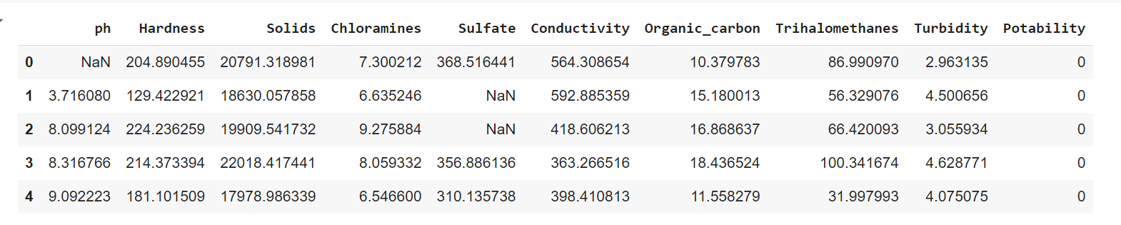
- tranforming the dataset in required format which is suitable of making model using Google colab like Modifying the column name which is incorrect .
df.rename(columns={'Sulfate': 'Sulphate'}, inplace=True)
df.head()
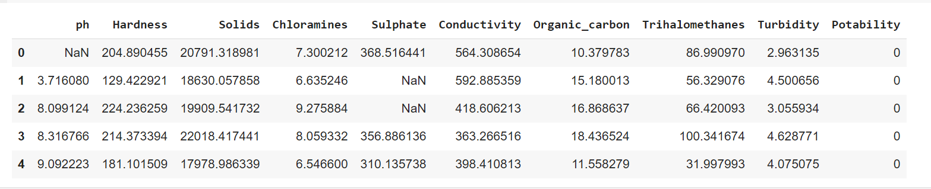
- used various charts to analyse the dataset like heatmap , scatter plot, box plot etc.
Checked whether any column have null values

plt.figure(figsize=(15,5))
sns.barplot(df.isnull())
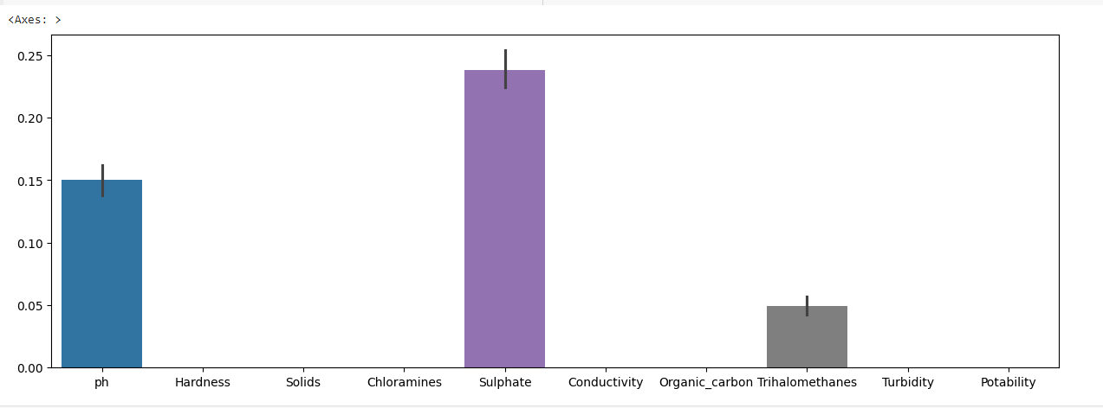

If null value present in any column here in ph, Sulphate and Trihalomethanes column have null value to fill that:
df["ph"]= df["ph"].fillna(df["ph"].mean())
df["Sulphate"]= df["Sulphate"].fillna(df["Sulphate"].mean())
df["Trihalomethanes"]= df["Trihalomethanes"].fillna(df["Trihalomethanes"].mean())

- divide your data into two part i.e. training and testing then created a suitable model which gives a higher accuracy (prediction will be nice). In this I have used random Forest Classifier model.
X = df.drop('Potability', axis=1)
y = df['Potability']
X_train, X_test, y_train, y_test = train_test_split(X, y, test_size=0.2, random_state=181, shuffle=True)
print(f"Training set: {X_train.shape}, Testing set: {X_test.shape}")

- used a model which is best suitable for prediction
dtree= DecisionTreeClassifier(criterion='gini', min_samples_split =10, splitter ='best')
dtree.fit(X_train, y_train)
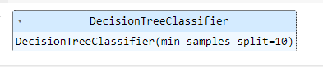
pred_y = dtree.predict(X_test)
print(f"Accuracy Score ={accuracy_score(y_test,pred_y)*100}")

- downloaded the google colab file in local pc
joblib.dump(dtree, 'water_purity_model.pkl')
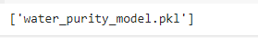
#the below code download the file
files.download('water_purity_model.pkl')

- created a GUI for user to Give input based on that provided parameter using Streamlit.

import streamlit as st
import joblib
import numpy as np

st.markdown(
"""
<h1 style='color: navy;'>Water Purity Prediction</h1>
<h2 style='color: navy;'>Enter the features to predict water purity</h2>
<style>
.stApp {
background-color: #a2c4e6; /* soft blue */
.stButton > button {
background-color: #d7e9f7; /* water theme blue */
color: navy;
}
</style>
""",
unsafe_allow_html=True
)
# Load the trained model
model = joblib.load('water_purity_model.pkl')
#st.title ("Water Purity Prediction")
ph = st.number_input("**PH**")
Hardness = st.number_input("**Hardness**")
Solids = st.number_input("**Solids**")
Chloramines = st.number_input("**Chloramines** ")
Sulphate = st.number_input("**Sulphate**")
Conductivity = st.number_input("**Conductivity**")
Organic_carbon = st.number_input("**Organic carbon**")
Trihalomethanes = st.number_input("**Trihalomethanes** ")
Turbidity = st.number_input("**Turbidity**")
# When the user clicks the predict button
if st.button("Predict"):
features =np.array([[ph,Hardness,Solids,Chloramines,Sulphate,Conductivity,Organic_carbon,Trihalomethanes,Turbidity]]) # Adjust according to your model's input shape
prediction = model.predict(features)
st.write("Prediction:","Water is safe to drink" if prediction ==1 else "water is not safe to drink")

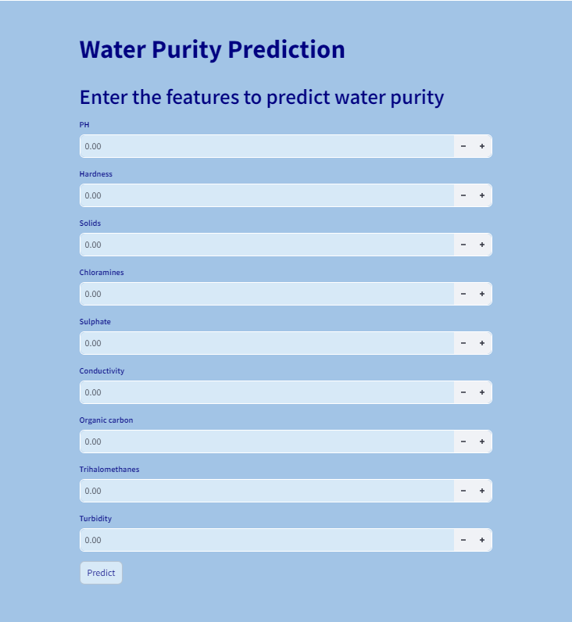

3. Results
3.1 Key Findings

- Data Insights: Identity some patterns or trend after implementing the project. For instance, you might find that certain features consistently correlate with water purity issues.
- Model Robustness: To make sure it generalizes well beyond the training dataset, examine how well it does with fresh or untested data.
- Feature Importance: Examine which characteristics such as pH, turbidity, hardness and others . which have biggest impact on the purity of the water.

3.2 Visuals:

plt.figure(figsize=(10,8))
sns.heatmap(df.corr(),annot=True)
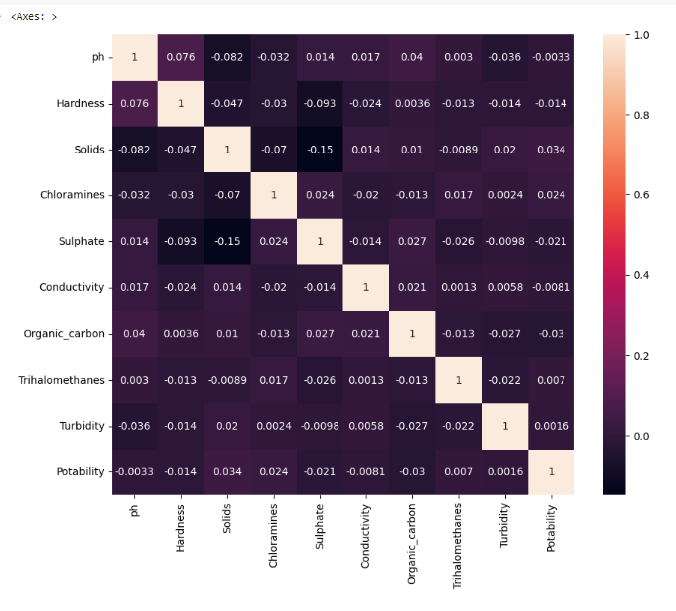
sns.scatterplot(df, x="ph", , y="Hardness",hue='Potability', palette='coolwarm')
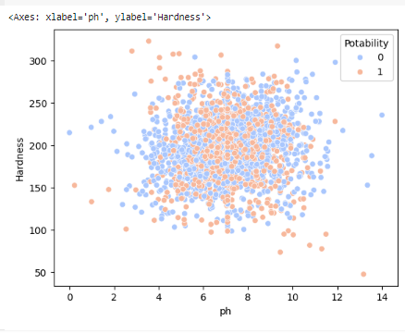

plt.figure(figsize=(15,5))
sns.barplot(df.isnull())
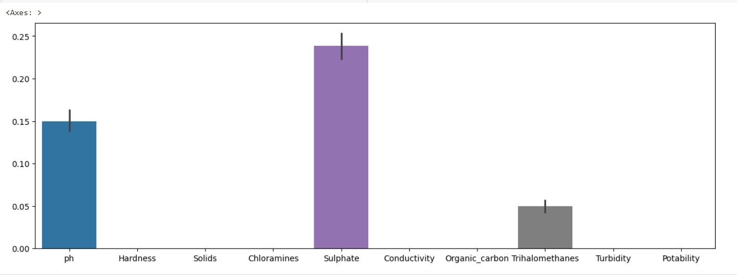

sns.displot(df['ph'])
plt.show()

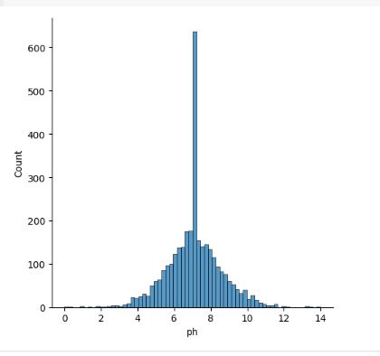

5. Conclusion
5.1 Summary
- Using a Decision Tree Classifier, the water purity prediction model seeks to ascertain whether water is potable based on a variety of physicochemical factors.
- The goal variable in the dataset indicates potability and includes characteristics like pH, hardness, solids, chloramines, sulphate, conductivity, organic carbon, trihalomethanes, and turbidity.
- With reliable results for both potable and non-potable cases, the model predicts potability for more samples with effectiveness.
- Future work will focus on improving the model's performance and creating a Streamlit GUI for user interaction.
- The model offers a useful instrument for evaluating water safety and a more effective substitute for conventional testing techniques.
- It can help with water quality monitoring, decision-making on water safety, and timely resolution of contamination problems.

5.2 Suggestions
- Incorporate Domain Knowledge: In order to comprehend the effects of various features and possible new variables to include, work with specialists in water quality.
- Regular Updates: To maintain the model current and correct, add new data to it on a regular basis.
- Model Evaluation: Use cross-validation to evaluate model performance in a more reliable manner.
- Feature Engineering: do Feature Selection Identify and retain the most relevant features to improve model performance and reduce overfitting.

6. References
From Youtube
From Google

